**A picture containing clipart

Description generated with very high confidence**

PUSHING THE CONTAINER ON DOCKERHUB

DevOps Certification Training

[**support@intellipaat.com**](mailto:support@intellipaat.com)

**+91-7022374614**

**US: 1-800-216-8930(Toll Free)**

**PUSHING THE CONTAINER ON DOCKERHUB**

**Step 1:** The first step is to login, it can be done using the following command:

$ docker login

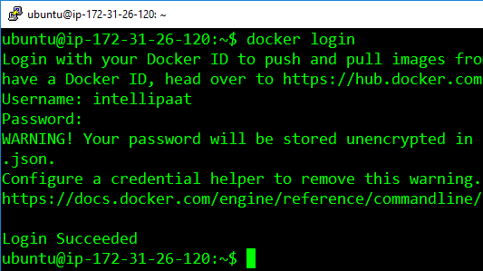

**Step 2:** Finally, for pushing your container on DockerHub, use the following command

$ docker push <username>/<container-id>

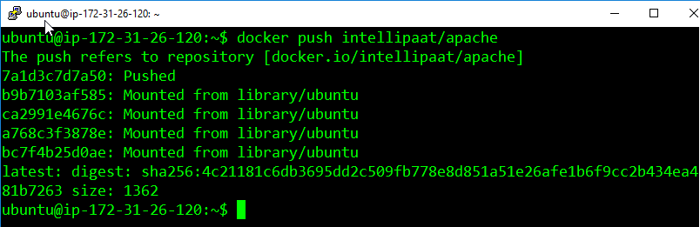

**Step 3:** You can verify the push on DockerHub

$ docker exec –it <container-id> bash

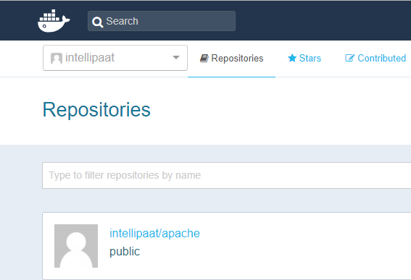

Now anyone, who wants to download this container. Can simply pass the following command:

docker pull intellipaat/apache